IVI and the People’s Republic of China
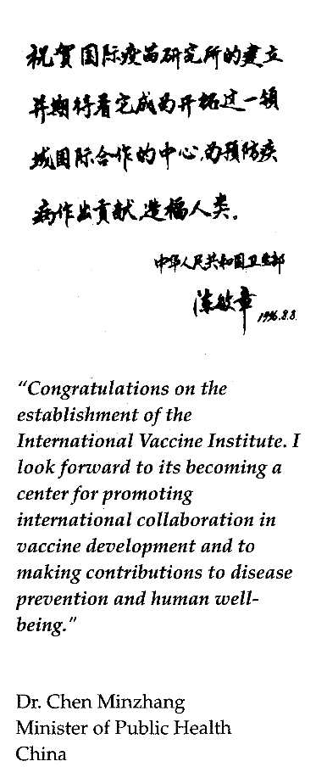
China: A State Party to the IVI Treaty
On January 13, 1997, the People’s Republic of China signed
the Agreement on the Establishment of the International Vaccine Institute
at the United Nations, becoming IVI’s 18th State Party.

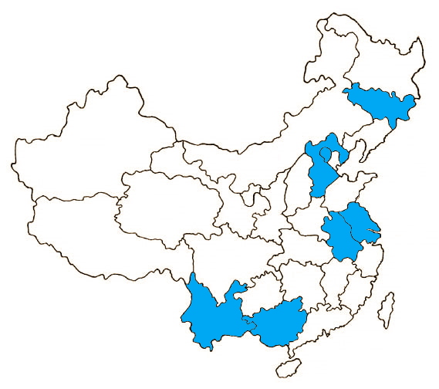IVI: Action across China

Anhui Province
- 2001-2003 Rotovirus/diarrhea study

Beijing
- 1999 Hib/meningitis study
- 2001-2003 Rotovirus/diarrhea study

Guangxi Province
- 2000-2007 DOMI program- Typhoid research and vaccination trial.

- 1998-2002 Hib/Meningitis incidence study
- Cohosted the 2015 International Symposium on Typhoid in Guilin

Hebei Province
- 2001-2003 Rotovirus/diarrhea study
- 2003 Shigella/dysentery disease burden and cost of illness studies

Jiangsu, Jilin, and Yunnan Provinces
- 2001-2003 Rotovirus/diarrhea studies

Shanghai
- 2002 Public health impact and cost-effectiveness studies on the Japanese Encephalitis vaccine

Zhejiang Province
- 1998 vaccine production workshop at Zhejiang Academy of Medical Sciences.

IVI: Award Winning Research in China
In 2001, IVI’s then lead scientist Dr. Xu Zhi Yi received China’s National Science and Technology Award(J-233-2-11) for his work on the Hepatitus A vaccine.
